DATA ANALYTICS LAB MANUAL

Lab 3 – NumPy Operations

1. Introduction
In this lab, we used NumPy to perform different numerical operations. NumPy helps in handling large data efficiently and is widely used in data analysis and scientific computing.

2. Creating NumPy Arrays (1D, 2D, 3D)
In this step, we created different types of arrays.
Explanation:
- 1D array → single row of data
- 2D array → rows and columns (matrix)
- 3D array → multiple matrices
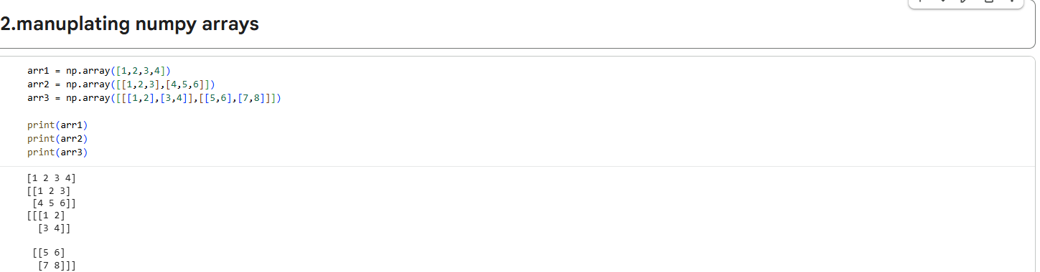
(Showing creation of 1D, 2D, 3D arrays)

3. Array Indexing, Slicing, and Reshaping
In this step, we accessed and modified array elements.
Explanation:
- Indexing → access specific element
- Slicing → access multiple elements
- Reshaping → change array dimensions
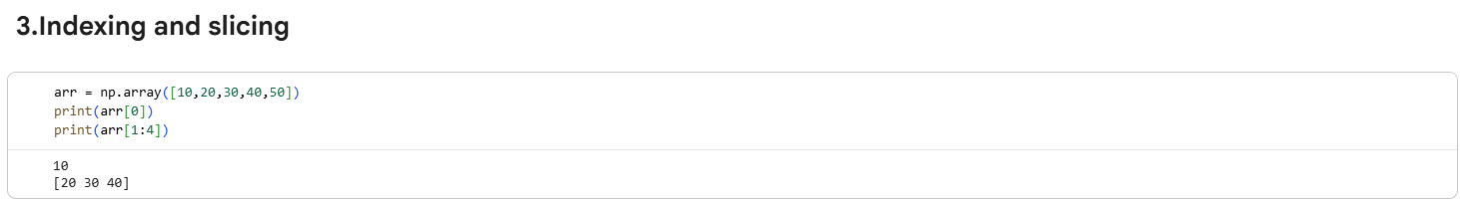
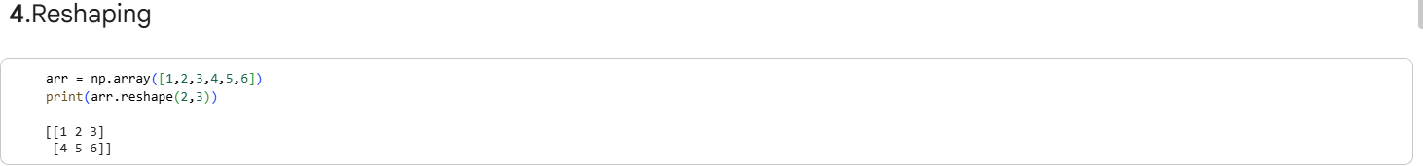
(Showing indexing, slicing, reshape output)

4. Mathematical Operations
In this step, we performed mathematical operations on arrays.
Explanation:
- Element-wise operations (addition, multiplication)
- Broadcasting (operations on arrays of different sizes)
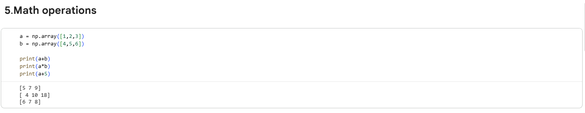
(Showing element-wise and broadcasting operations)

5. Statistical Functions
In this step, we calculated statistical values.
Explanation:
- Mean → average value
- Median → middle value
- Standard deviation → spread of data
- Percentiles → distribution of data
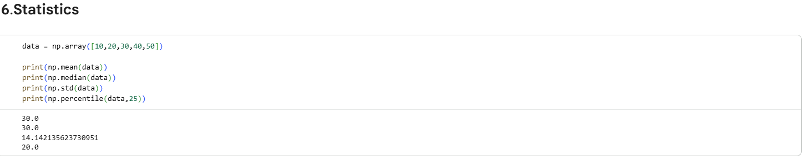
(Showing mean, median, std, percentile output)

6. Linear Algebra Operations
In this step, we performed matrix operations.
Explanation:
- Dot product
- Matrix multiplication
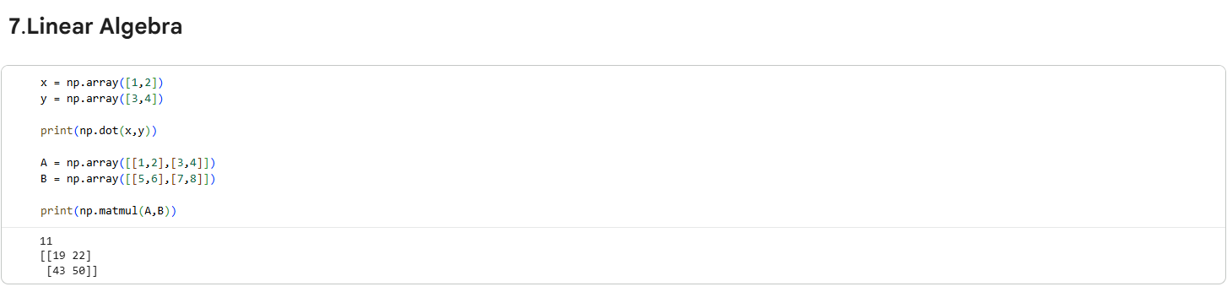
(Showing dot product and matrix multiplication)

7. Random Number Generation
In this step, we generated random numbers.
Explanation:
- Random values are used for simulations and testing
- Sampling helps in selecting random data
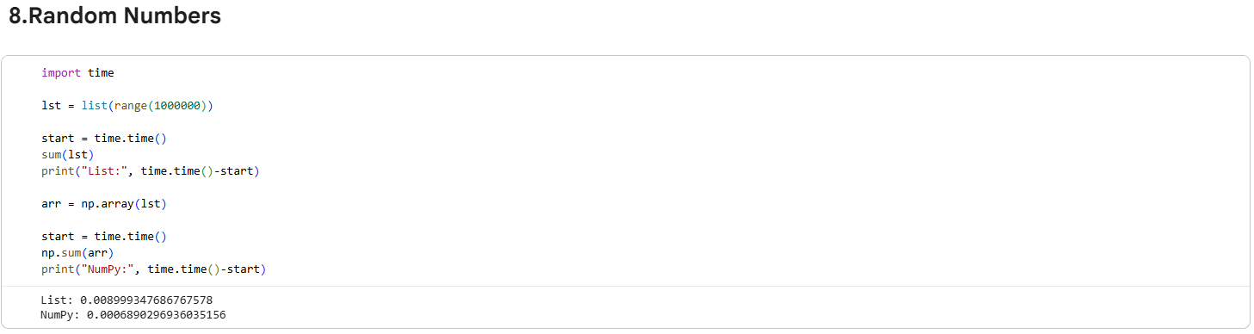
(Showing random numbers and sampling)

8. Dataset Usage (Temperature / Stock Data)
We used a dataset such as temperature measurements or stock prices to apply NumPy operations.

9. Performance Comparison
In this step, we compared Python lists with NumPy arrays.
Explanation:
NumPy operations are faster and more efficient than normal Python lists.

10. Conclusion
In this lab, we learned how to use NumPy for array creation, manipulation, and data analysis. We also observed that NumPy is faster and more efficient for large datasets compared to Python lists.

11. Output Summary
- Created 1D, 2D, 3D arrays
- Performed indexing, slicing, reshaping
- Applied mathematical and statistical operations
- Performed linear algebra calculations
- Generated random numbers
- Compared performance with Python lists

